Chapter 5

Occurrences of Major Disasters -- 1900-2017

Disasters are generally categorized as natural, man-made or technological in origin. Their size and severity are somewhat arbitrary depending on their context; incorporating such factors as economic loss, human costs in lives and injury, geopolitical impacts, infrastructural frameworks and geographical consequences both, human and geo-physical. Using the United Nations Office for Disaster Risk Reduction (UNISDR) definitions[1] hazards are described in various categories consisting of subsets that include further refinement of the hazard specifications. These hazard categories and subsets are often geographically specific to a region or location and vary in severity.

Because the major focus of this book entails the analysis of disaster ideas, the use of the numerous and varied classifications and individualized descriptors used in formulating the vast vocabulary of disaster terms are significant. How, and in what context the terms are found in research papers, directly affects analysis and the scope in which idea creation can contribute to the further understanding of disasters and their relative impact on research science and its application for solving real world problems. For most research designs and methodological approaches, the use of limited terminology may not necessarily create a major obstacle for analytical purposes. Text analysis and idea development processes however, maximize the contextual meaning and the pairing of informative terms needed within the cognitive learning application of this methodology that is often found lacking in other methodologies. For purposes of this paper, we will use the more standard identification of hazard terminology found within the universal framework of disaster studies, with full acknowledgement that increase specificity may be used by different data collectors depending on the objectives and needs of the individual research.

Using a common terminology structure, most hazard causing disasters are generally classified as follows: [**avalanche**](https://www.preventionweb.net/hazards/view/67), snow avalanche, snow slide; [**cold wave**](https://www.preventionweb.net/hazards/view/56), extreme weather, extreme temperature, cold temperatures; [**cyclone**](https://www.preventionweb.net/hazards/view/58), hurricane, tropical storm, tropical depression, typhoon: [**drought**](https://www.preventionweb.net/hazards/view/59), deficiency of precipitation, desertification, pronounced absence of rainfall; [**earthquake**](https://www.preventionweb.net/hazards/view/60), seismic, tectonic; [**epidemic & pandemic**](https://www.preventionweb.net/hazards/view/61) **epidemic**, bubonic plague, cholera, dengue, non-pandemic diseases, typhoid; **pandemic**, H1N1, HIV, smallpox, tuberculosis; [**flood**](https://www.preventionweb.net/hazards/view/62), inundation includes, flash floods; [**heat wave**](https://www.preventionweb.net/hazards/view/63), extreme weather, extreme temperature, high temperatures; [**insect infestation**](https://www.preventionweb.net/hazards/view/64), locust, plague, African bees; [**land slide**](https://www.preventionweb.net/hazards/view/65), debris flow, mud flow, mud slide, rock fall, slide, lahar, rock slide and topple; [**NBC**, nuclear, biological, chemical](https://www.preventionweb.net/hazards/view/103) biohazard risk, chemical contamination, nuclear radiation risk; [**storm surge**](https://www.preventionweb.net/hazards/view/68), coastal flood, wave surge, wind setup; **t**[**echnical disaster**](https://www.preventionweb.net/hazards/view/69), chemical spill/leak, explosions, collapses, gas leaks, urban fire, oil spill, technical failure; [**tornado**](https://www.preventionweb.net/hazards/view/70), waterspout, twister, vortex; [**tsunami**](https://www.preventionweb.net/hazards/view/71); [**volcano**](https://www.preventionweb.net/hazards/view/72), crater, lava, magma, molten materials, pyroclastic flows, volcanic rock, volcanic ash; and **w**[**ild fire**](https://www.preventionweb.net/hazards/view/73), bush fire, forest fire, uncontrolled fire, wildland fire.[2]

Disasters by definition vary depending on the specifics of the circumstances, event or context of its usage. Webster defines disaster as “a sudden [calamitous](https://www.merriam-webster.com/dictionary/calamitous) event bringing great damage, loss, or destruction.”[3] Whatever the specific definition used, the term ‘disaster’ is often overused when describing an emergency event or unusual occurrence. This is especially true when used in the context of news reporting, social media and general public vernacular. In terms of research terminology, meanings are often more precise for delineating distinctions for scientific measurement, specific analysis or theoretical understanding.

The statistical framework in which disasters are often referred generally focus on several factors such as location, deaths and injuries, costs in damages, and disaster type or classification. One such statistical database, *The International Disaster Database* managed by the Centre **for Research on the Epidemiology of Disasters (CRED)**[4]**, requires that disaster events meet a minimal requirement before being qualified for inclusion into their disaster database. Those criteria include:**

* Ten (10) or more people reported killed
* Hundred (100) or more people reported affected
* Declaration of a state of emergency
* Call for international assistance

**Global Impacts**

Although statistical numbers may vary depending on the database consulted, general trends and datasets often follow closely among the accumulating reporting bodies. Figure 1 illustrates the disaster impacts by the UN Office for Disaster Risk Reduction (UNISDR) describing the various impacts associated with disaster covering damage costs, number of individuals impacted and the number of deaths occurring between 2000 and 2012.[5]

**Figure1: Disaster Impacts Worldwide, 2000-2012**

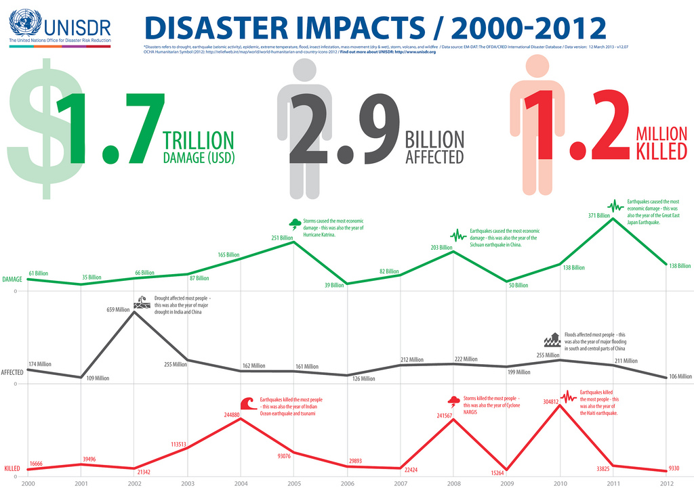

As noted in Figure1, certain events can produce significant spikes or drastic declines within specific timeframes. Databases that are more hazards specific may produce similar data but such data may be displayed and analyzed differently depending on the focus and framework of the research. For purposes of this book, we will view the data with a common perspective while addressing general trends, patterns and occurrences from a global viewpoint. Those wanting to approach disaster research statistics with more specificity can find ample sources and relevant information within the references provided.

Figure 1 shows the overall damage costs in 2000 for all disaster categories was $61Billion (US Dollars). By 2012, the number fluctuated up and down to $231B (USD). Individual disasters such as Hurricane Katrina in 2005 caused an estimated $251B in damage, earthquakes such as the Sichuan earthquake in China in 2008 caused $203B, and in 2011, again earthquakes were the major cause of damage reaching $371B. The Great East Japan Earthquake was a major contributor to this increase.

According to UNISDR figures during this period, persons affected by disasters in 2000 were estimated at 174 million and remained relatively steady at this rate with 106 million persons affected in 2012. One exception is noted in 2002, where severe droughts in India and China that year brought the number of persons impacted to 659 million. In 2010, flood hazards overall, and specifically floods in central and south China, caused significant impact to populations that year.

The number of deaths caused by disasters during the 2000-2012 period saw the lowest numbers in 2000 (16,666), 2009 (15,264) and 2012 (9330). The highest death tolls were recorded in 2004 (244,880) mostly by earthquakes, specifically by the Indian Ocean earthquake and the subsequent tsunami; 2008 (241,567) caused by storms and in particular Cyclone NARGIS; and 2010 (304,812) deaths were again the result of earthquake occurrences, specifically the Haiti earthquake.

**Specific Hazard Occurrences**

Disaster statistics involving specific hazards for the period 2000 to 2016 in Figure 2 provide an illustration of the diversity of occurrences. The data indicate that flood frequencies at 43% far exceed other hazards worldwide.

**Figure 2: Disaster Occurrences by Hazard 2000-2016**

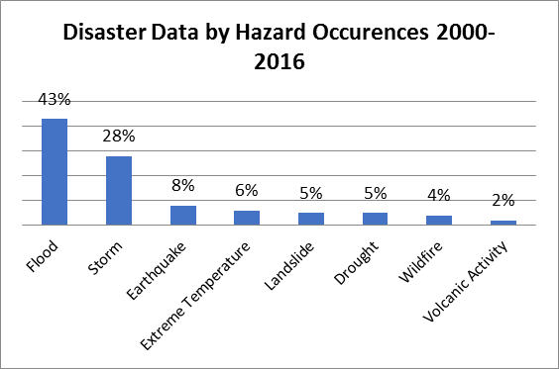

Storms, which include all types of windstorms, tornadoes, cyclones and extreme weather events, made up 28% of all hazard occurrences for this period. Earthquakes, extreme temperatures, landslide, drought and wildfire followed. The lowest occurring hazards were those categorized as volcanic activities making up approximately 2% of all natural hazard events.

**Figure 3: Impact of People Affected by Hazard 1992-2012**

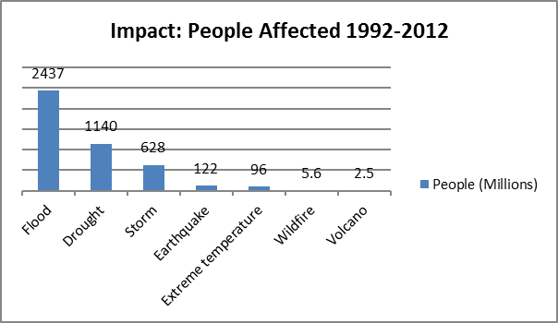

Source: EM-DAT 2012. http://www.emdat.be

From 1992 to 2012 (Figure 3), flood was the hazard most likely to affect the lives of those in the impacted areas. This was followed by drought, affecting approximately 1.14 million people and storm occurrences affecting 628 million people. Earthquake and extreme temperature events affected 122 million and 96 million people respectively. The least impacting hazard was volcano events, which impacted 2.5 million.

**Figure 4 depicts the amount of damage from specific hazard over the period 1992-2012 worldwide. Storms, which we categorize as windstorms consisting of cyclone, hurricane, tornado, etc. produced the most damage at $720 billion (USD). Damaged caused from earthquakes was** $636 billion. Hazard damage of $480 billion was the result of flood occurrences. Damage caused by drought, extreme temperature and wildfire was considerably less by comparison. Volcanic activity was again the least impacting hazard over this period.

**Figure 4: Hazard Damage Impacts 1992-2012**



The number of people killed by natural disasters over this 20 year period exceeded 1.3 million. Similarly, earthquake and storm continually rank in the top 3 impact natural hazards. Figure 5 shows the number of people killed during this timeframe by each specific hazard. Earthquakes by far were responsible for the majority of deaths totally 759,708. Storm, extreme temperature and flood caused a combined death toll just under 550,000. Deaths from drought, wildfire and volcanic activity were responsible for less than 5000 people killed.

**Figure 5: Number of People Killed by Hazard Occurrence 1992-2012**



Disaster statistics showing impacts to countries provides some interesting observations. Figure 6 lists the top 10 countries according to the number of people impacted. China out distanced all other countries and ranked number one with disasters impacting over 2.5 billion of its citizens over the 20 year period. India had 928 million people affected followed by Bangladesh at 139 million. The middle range of countries with impacted populations had between 92 and 64 million individuals affected. The country registering the lowest number of impacts from the top 10 countries was Viet Nan, having 30 million of its population affected by disasters between 1992-2012.

**Figure 6: Top 10 Countries by Persons Affected by Disaster 1992-2012**

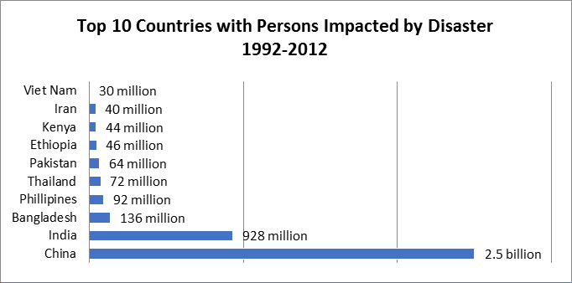



Over the past 20 years, the economic cost in damages attributed to disaster has increased. While less developed countries may head the top 10 list of their populations being more impacted, the more developed countries occupy more of the top 10 leaders with regard to cost in damages brought on by disasters. Figure 7 provides the top 10 counties who have incurred the highest loss in costs. The top three leaders for total loss in property costs are the United States, Japan and China. These three countries combined for a total loss in just under $1.3 (USD) billion in damages occurring. The remainder of the top 10 leading countries in damages incurred ranged between $45 billion and $31 billion. Australia secured the last spot incurring approximately $28 billion in losses.

**Figure 7: Top 10 Countries with Highest Damage Impact**

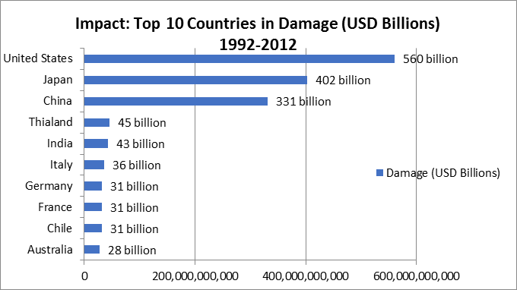



In 2017 alone, disasters caused the United States $306 billion in total damages. This was the result of $265 billion losses brought on by hurricane storms. The remainder of the loss was the result of 16 events causing $1 billion in damages each.

Figure 8 listed the top 10 countries ranked by the largest number of person killed by disasters. Haiti led all countries in this category with 230,675 people kill by disaster. From 1992 through 2012, Haiti has had approximately 23 hazard events. One of the largest and most deadly occurred on January 12, 2010 when Haiti was struck by a magnitude 7.0 earthquake. The number of people killed was estimated between 46,000 and 316,000. This exceptional wide range in estimated deaths is one example of the difficulty in capturing accurate statistical data in certain geographical areas of the world.

Four countries had over 100,000 deaths by disaster during this period and included Indonesia, Myanmar, China and India. Pakistan, Russia, Sri Lanka registered 85,322, 61,152 and 36,000 respectively. Finishing out the top 10 were Iran with 32,680 people killed and Venezuela incurring 30,163 deaths attributed to disaster for the 20 year period.

**Figure 8: Top 10 Countries Impacted by People Killed 1992-2012**

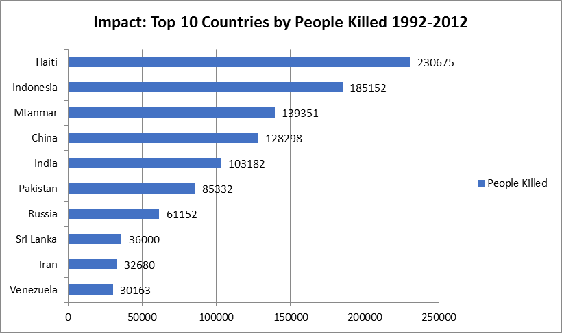

S

o

u

r

c

e

:

E

M

-

D

A

T

2

0

1

2

.

h

t

t

p

:

/

/

w

w

w

.

e

m

d

a

t

.

b

e

**Historical Natural Disaster Trends**

As you can see from Figure 9, the number of deaths globally have decreased significantly in recent decades from a recorded high in the 1920-1929 period. There are of course multiple factors attributed to and directly responsible for this decrease. Breakthroughs in medical science and better overall health services are one cause. The lessening of the gap between under developed countries and those more affluent countries. Better management of disaster operations and subsequent support services and overall, the increased emphasis on preparedness, prevention, response and community education directed toward individual disaster awareness and responsibility.

This in no way of course means that the work is finished. Even with the present and future technological advances disaster continue to occur and the impacts of those events are still devastating and economically foreboding. Droughts continue to occur with frequently, as do earthquakes, especially in poverty stricken locations where services, aid and resources are scarce, and country capacities and capabilities are well below sufficient to adequately meet the challenges and impact of the disaster.

**Figure 9: Deaths Attributed to Natural Disaster 1900-2015**

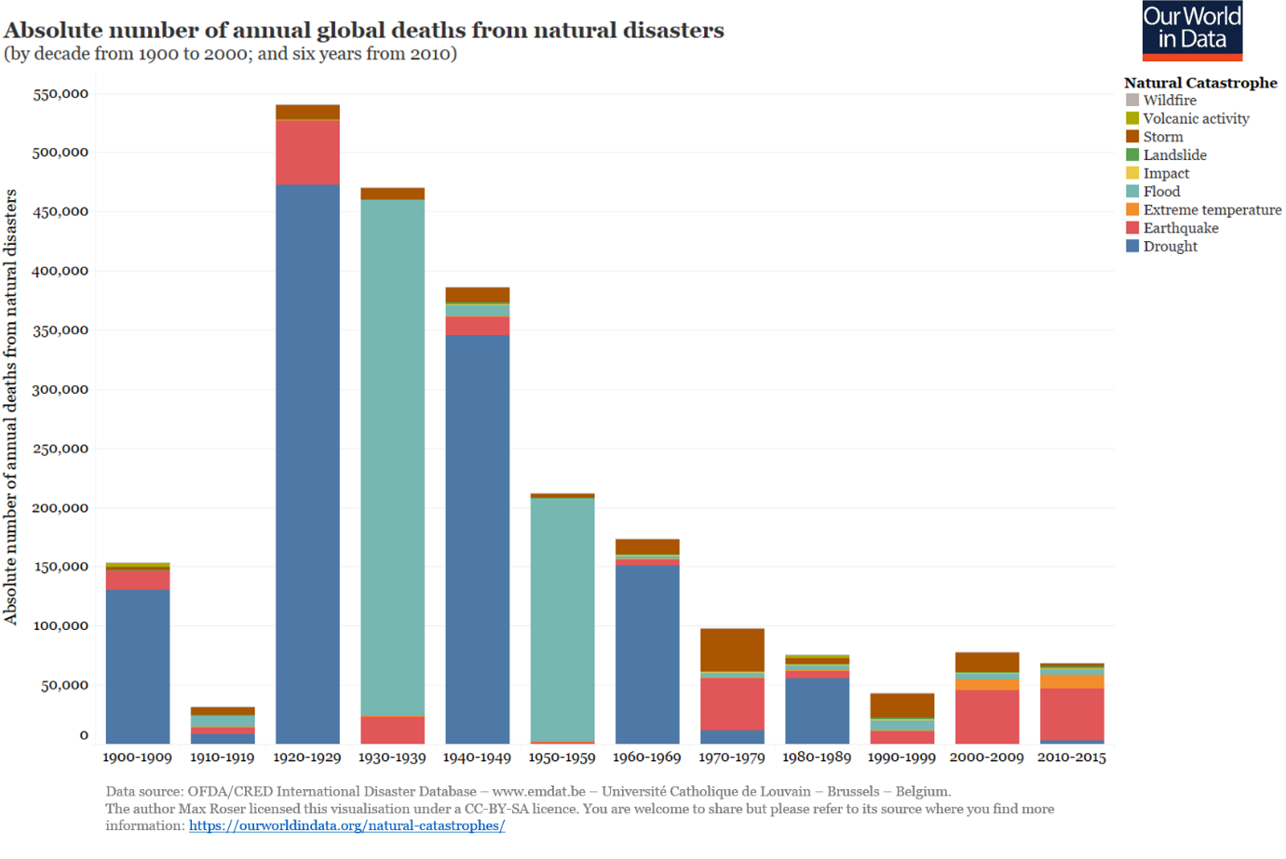

If you look at the frequencies of natural disasters over the last century and into the first decades of the 21st Century, you will notice a steady increase beginning in 1960 and continuing into 2000, followed by a downturn up to 2017. By all news accounts, one would think disasters are out of control but the true global trend from a visual perspective indicates a reduction in natural events over the past decade. However, a detailed analysis of data would have to be examined before attributing impacts and causation to these data.

**Figure 10: Recorded Natural Disaster Events 1900-2017**

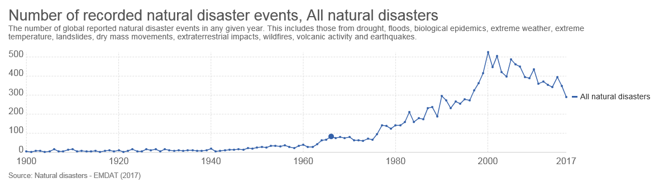

Figure 11 graphically depicts the number of people affected by natural disaster over the last 117 years. Referring back to Figure 3 provides a snapshot of the correlation between the two datasets and the apparent fluctuation of these data beginning in the 1960s and continuing to the present time period. As the world population continues to increase over time, the incidents of homeless, displaced populations, and the human costs resulting from disasters may well continue this pattern.

**Figure 11: Impact of Affected People from Natural Disasters 1907-2017**

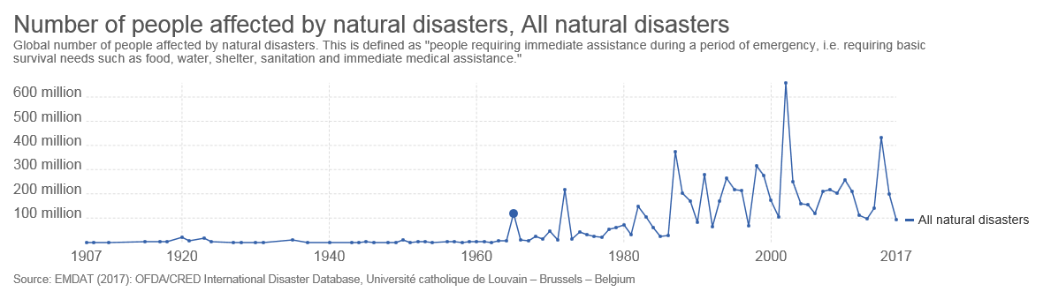

For the first 80 years of the 20th Century, losses caused by natural disasters remained relatively low and steady (Figure 12). Beginning around 1980 the increase in disaster costs began to increase with continuous fluctuations depending on the year. It is certain that with the losses incurred the by the United States alone, 2017 may be a record setting year for disasters losses worldwide. The rise in disaster loss can be attributed to many factors. Population growth affects societal infrastructures, increasing urbanization and in many cases industrialization. Product consumption directly impacts costs associated with housing, food production, manufacturing, and a host of related services and ancillary by-products.

**Figure 12: Impact of Damage from Natural Disasters 1900-2017**

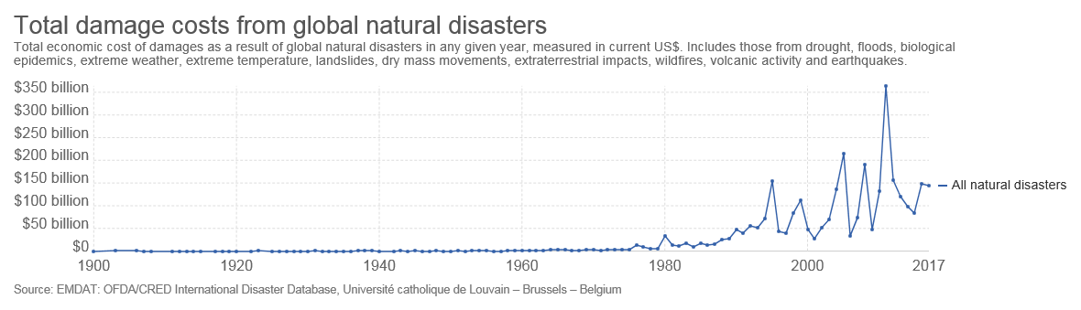

As the costs of items used in modern society increase, damage from natural disasters will invariably increase as well. The impacts attributable to climatic and environmental conditions may also play a role in this increase brought on by more severe levels of hazard phenomena. Disasters directly impact health costs and other economically affected elements of a modern society. Figure 12 illustrates the increases attributable to disasters over the last century. The increase in disaster events began to increase in the 1960s and 1980s (Figure 10), so too have the costs of damage increased. These data show a continued fluctuation in costs as data are collected into the 21st Century.

**Summary**

In the short term at least, disaster data indicate that deaths, hazard occurrences, and the number of persons affected by natural phenomena will likely increase. Whether this increase will continue for an extended period is unknown. The challenges remain, and in order to prepare, prevent, respond, mitigate and recover in an effective and efficient manner to disasters will require an efficient research design to meet the increase. Why and what is researched depends on correctly identifying the needs of the professional and the public alike. The mass of research papers and articles being published at today’s rates are impossible to accurately capture and analyze through manual processes. Correctly comprehending what is required in the field, in concept and in theory, can effectively and efficiently be accomplished through text analysis and idea creation. New designs must be utilized to meet the increasing complex systems and the complex disasters we are facing in today’s modern world.

1. UN Office for Disaster Risk Reduction (UNISDR). *PreventionWeb*. <https://www.preventionweb.net/english/hazards/>. Accessed January 3, 2018.
2. Ibid.
3. "Disaster." Merriam-Webster.com. Merriam-Webster, n.d. Web. 4 Jan. 2018.
4. “EM-DAT | The International Disasters Database.” EM-DAT | The International Disasters Database, www.emdat.be/.
5. Ibid, UNISDR, 2018.